SSD AE2 – GuideLK (Tourism Management System)

Things to do,

1. ICONIX process

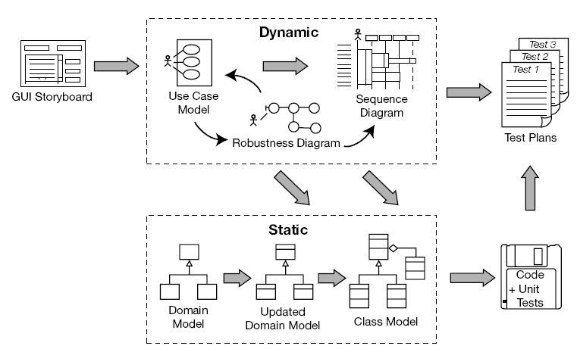

* Activity UML Diagram of GuideLK
* Travel Agent Activity
* Package Activity
* Customer Activity
* Booking Activity
* Transportation Activity
* Feedback Activity
* Complaint Activity

Features of Activity UML Diagram

* Admin user can create, update, delete, and search Travel Agent.
* Its shows the activity flow of editing, adding and updating of Package.
* User will be able to search and generate report of customer booking details.
* Travel Agent, Package and Transportation objects are interlinked.
* Its shows the full description and flow of Travel Agent, Booking, Transportation, Customer and Package.
* Admin user can view all Feedbacks.
* Admin user can view all Complaints and reply.

Activity Diagram

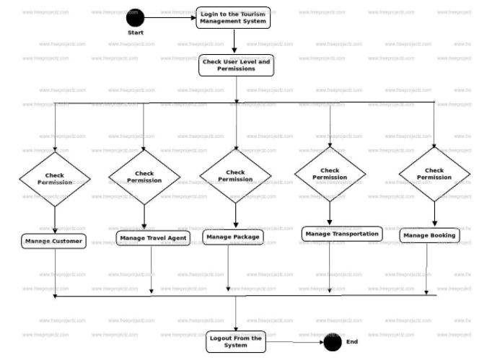

Logging Activity Diagram

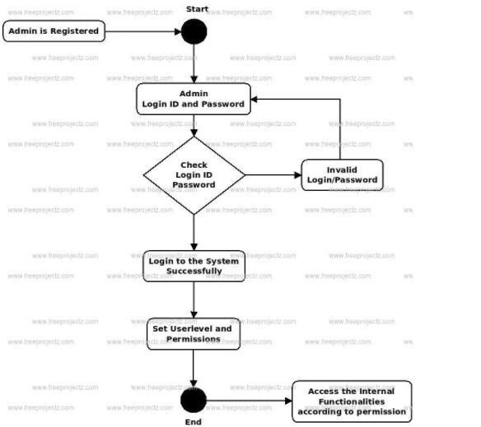

Class Diagram

* Customer Class
* Travel Agent Class
* Package Class
* Transportation Class
* Booking Class
* Hotel Class
* Feedback Class
* Complaint Class
* User Class
* Role Class
* Permission Class

Class and Their Attributes

* **Customer Attributes** – customer_id, customer_name, customer_email, customer_mobile_no, customer_tel_no, customer_address1, customer_address2, customer_created_by, customer_created_date, customer_last_modified_by, customer_last_modified_date, customer_status.
* **Travel Agent** –travel_agent_id, travel_agent_name, travel_agent_email, travel_agent_mobile_no, travel_agent_tel_no, travel_agent_address1, travel_agent_address2, travel_agent_created_by, travel_agent_created_date, travel_agent_last_modified_by, travel_agent_last_modified_date, travel_agent_status.
* **Package** – package_id, package_name, package_amount, package_total, package_type, package_description, package_created_by,

package_created_date, package_last_modified_by, package_last_modified_date, package_status

* **Transportation –** transportation_id, transportation_vehicle_no, transportation_ v_type, transportation_ description, transportation_created_by,

transportation_created_date, transportation_last_modified_by, transportation_last_modified_date, transportation_status

* **Hotel –** hotel_id, hotel_name, hotel_type, hotel_category, hotel_tel_no, hotel_address1, hotel_address2, hotel_created_by,

hotel_created_date, hotel_last_modified_by, hotel_last_modified_date, hotel_status

* **Booking –** booking_id, booking_title, booking_type, booking_date, booking_description, booking_created_by,

booking_created_date, booking_last_modified_by, booking_last_modified_date, booking status

* **Feedback –** feedback_id, feedback_description
* **Complaint –** complaint_id**,** complaint_description
* **User –** user_id, user_role_id, user_name, user_email
* **Role –** role_id, role_title, role_description
* **Permission –** permission_id, permission_role_id, permission_title, permission_module, permission_description

**Note: Above mention classes and attribute can change in the development stage based on some mappings.**

Classes and their methods

**Customer** – createCustomer(), updateCustomer(), deleteCustomer(), searchCustomer()

**Travel Agent** – createTravelAgent(), updateTravelAgent(), deleteTravelAgent(), searchTravelAgent()

**Package** – createPackage(), updatePackage(), deletePackage(), searchPackage()

**Transportation** – createTransportation(), updateTransportation(), deleteTransportation(), searchTransportation()

**Hotel** – createTransportation(), updateTransportation(), deleteTransportation(), searchTransportation()

**Booking** – createBooking(), updateBooking(), deleteBooking(), searchBooking()

**Feedback** – createFeedback(), updateFeedback(), deleteFeedback(), searchFeedback()

**Complaint** – createComplaint(), updateComplaint(), deleteComplaint(), searchComplaint()

**User** – createUser(), updateUser (), deleteUser (), searchUser()

**Role** – createRole(), updateRole(), deleteRole(), searchRole()

**Permission** – createPermission(), updatePermission(), deletePermission(), searchPermission(), assignPermission()

Class Diagram

